**Dog Details Breed Wise**

**Send Feedback**

There are many dog lovers in this world. Two brothers Dave and David are also one of them.

They decided to build a website for such people and also thought about its functionality -

1. Clicking on the 'Get Image' will get you a random image of a new breed only(i.e. you need to change the breed in the dropdown to make it work again.)

2. Clicking on the 'Next' button will get you a new random image of the same breed.

Dave suggested to build an API for it and use it on the web page. Dave gave the documentation of this API to you and asked you to complete the web page.

**Link for the API - https://dog.ceo/dog-api/documentation/**

**The webpage looks like this -**

[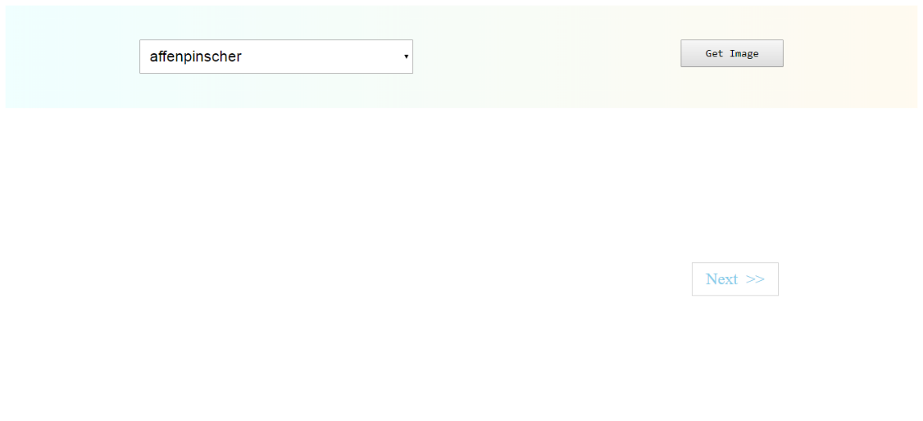](https://ninjasfiles.s3.amazonaws.com/0000000000002039.png)

**The image gets shown on the web page like this -**

[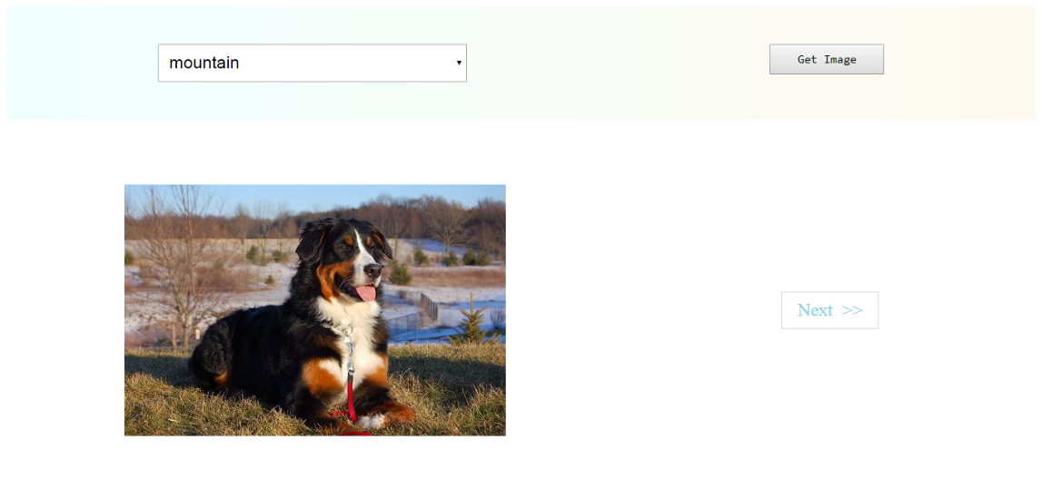](https://ninjasfiles.s3.amazonaws.com/0000000000002040.png)